EEC134 Final Report
Team #Oreo

Members: Kurt Norris, Brenton MacDonald, Baban Malhi, Lakshay Seth
Date :- June 4, 2015

Procedures
Overview:
Our team’s goal after the first quarter for this radar project was to shrink the overall design of the radar system as well as to make it as efficient as possible. We chose to create one PCB that would have the same functionality as the radar system we built by the end of the first quarter. We generated a triangle wave using the Arduino and DAC chips that fed into a VCO. The generated signal was sent through a power amplifier and then split to an output antenna and a mixer. The mixer mixed the input signal and the received signal, which was also sent through a power amplifier, and then passed the resulting signal into a low-pass filter. The output of the low pass filter circuit would be fed into a computer where an audio recording can be produced and analyzed by MATLAB in order to determine distance and speed. All components were surface mount in order to reduce the overall size and weight of our final PCB.
Process:
- In the first month of the second quarter, our group researched and found surface mount components that would be suitable for our new design. The basic block diagram did not alter much, but the components we were going to use in our final PCB design changed numerous times as issues were pointed out during our group presentations as well as discussions with professor Leo. The final block diagram that we used when building our PCB design in KiCad can be seen below.
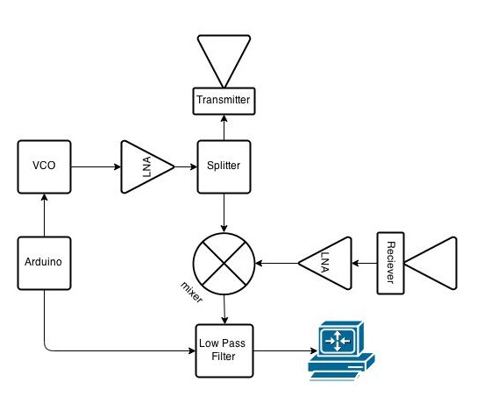
Figure 1. Block Diagram for Radar System

The various components we have in our final block diagram are as follows:
  - The Arduino step up consisting of the ATmega328P and MCP4921 chips along with the associated circuit components used to produce a triangular wave.
  - CVCO55CC-2328-2536 VCO that took the input triangle wave and produced and RF signal that centered approximately 2.4Ghz.
  - LNA power amplifier circuits from lab 2. We took this LNA design and put one between the VCO and the splitter as well as between the receiving antenna and the LO port of the mixer.
  - SP-2U2+ splitter that split the 2.4Ghz signal to a transmitting antenna and the mixer.
  - MAC-42MH mixer that mixes the received signal and the reference signal and passed it onto the low pass filter circuit.
  - The low pass filter from lab 6 using the OPA4228 chip and associated circuit components was used to filter out the high frequency signals coming from the mixer. The output of the low pass filter would be connected to a computer for external processing via an audio cable.
  - A computer with Audacity and MatLab to process the received radar signal.
  - Coffee cans from the previous quarter used as our transmitting and receiving antennas.
- We started creating our new PCB design in KiCad half way into the second quarter using the skills we learned from the first quarter.. This design was also a work in progress. As our components changed throughout the quarter, the PCB design also changed accordingly. The final schematic built using Kicad can be seen below:
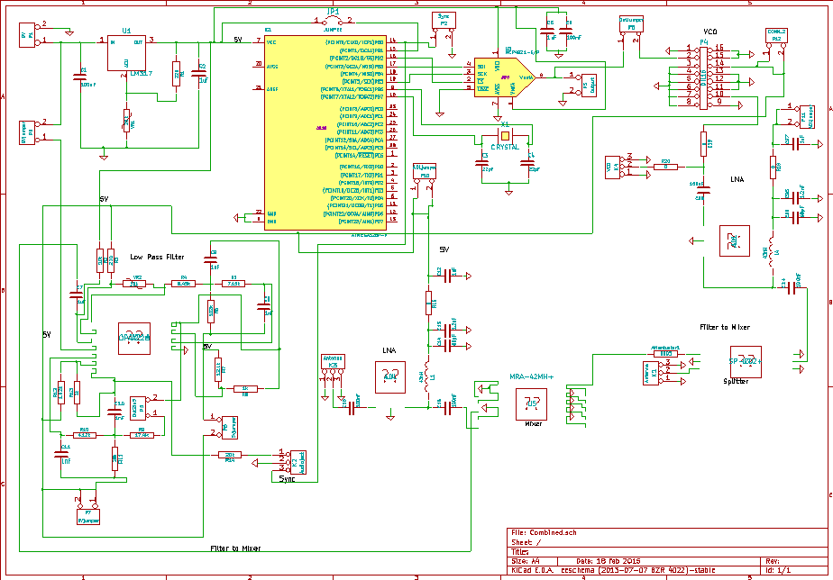
Figure 2. Final KiCad Schematic for Radar System
Once we had a PCB design that we felt was good we presented it to professor Leo and two PCB specialists. Our PCB design had numerous flaws that we were unaware of due to our lack of experience designing PCBs. Some flaws we had in our design are as follows. We had excessive traces on the board and many weird angles that they connected at. We learned that this presents the potential issue of acid traps that can occur in the manufacturing of the PCB. Over time this residual acid could lead to a trace being weakened or losing continuity altogether. Another issue was our power traces were the same size as all other traces on the board. The issue with this was that the current draw for all the components on the board may have exceeded the current carrying capabilities of regular traces. The last issue that we had was not having via holes to ground along the perimeter of the RF traces on the PCB in order to reduce the noise to and from the RF trace. After correcting all these problems by: cleaning up our traces, making our power trace larger and adding via holes along the RF trace, we got our PCB design approved and sent off to get manufactured.
We also chose to have three PCBs thinking ahead for trouble shooting ability if our combined PCB design did not work. Our three PCBs consisted of one board that had the entire design one it, a second board that only consisted of the RF circuitry, and the third board consisted of the arduino set up along with the low pass filter circuit. These three designs can be seen in below:
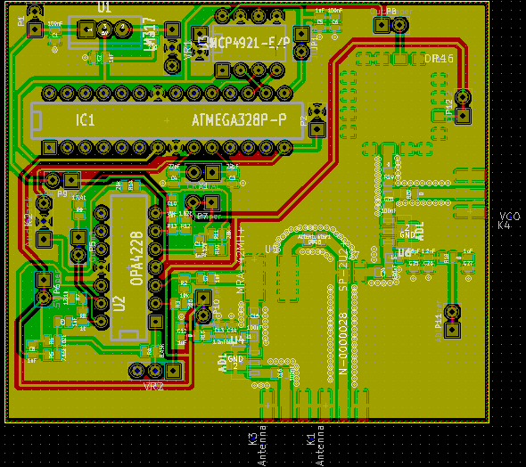
Figure 3. Combined PCB Design (RF, Arduino, and Low Pass Filter)
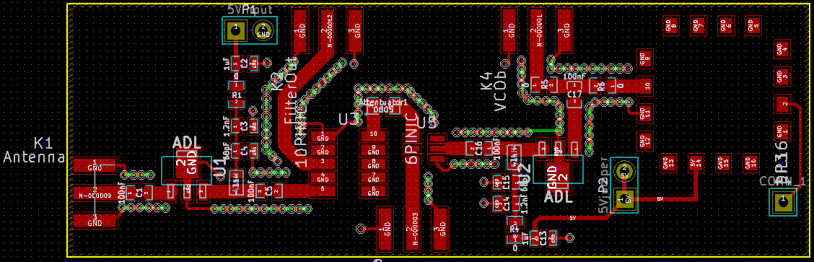
Figure 4. RF Only PCB Design
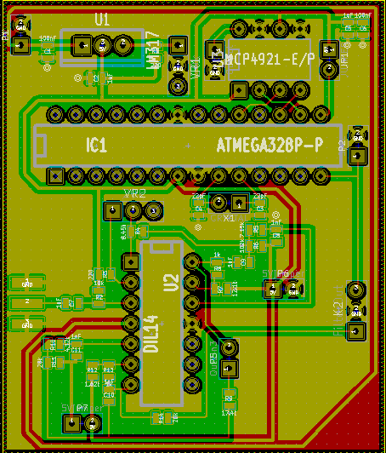
Figure 5. Arduino and Low Pass Filter PCB Design

- At the beginning of our third quarter, we received our PCB designs and began the assembly process. We chose to build the PCB that contained our whole design first, hoping that it would work and would not have to build our other PCBs. Using learned skills from the first quarter of this course, we built our PCB using mostly solder paste and a toaster oven. A majority of our resistors, capacitors, and inductors were 0603 surface mount components. Many of these were mounted to the PCB by using flux, solder paste and heat from the toaster oven until the solder paste became shiny. Cooling would then attach the components firmly to the PCB. The larger components such as the the various sockets and variable resistors were soldered to the PCB using solder and a soldering iron since they were through-hole mountable. This process was very long and tedious, but the board was eventually built and tested. These results can be found in the next section of the report.
Results and Discussions
There were multiple steps when our group was trying to test whether or not out PCB design worked for our custom radar design. The process that we went through along with the subsequent results are described below.
- The first test that our group put our PCB through was the ground test. For this test, we took a multimeter and check resistances at various test points in our PCB design. We concluded that most of the board was clear of any major ground issues except in the RF circuitry, Consulting with Professor Leo, he informed us that there may be a DC short to ground but not at the 2.4GHz frequency we were operating at. Evidence that confirmed Professor Leo’s comment was when we removed the RF Mixer from the PCB, the ground issue appeared to disappear. We remounted the mixer to the PCB moved onto our next testing phase.
- Next our group wanted to cautiously power on parts of the PCB one section at a time. We intentionally put in multiple jumper pins in our PCB design to control the power flow to the various components on the board. We started this test by removing all the IC chips from the board as to avoid damaging them. Next we hooked up an external power supply to our power terminals and supplied the necessary 9VDC to the circuit. Next we adjusted the variable resistor in out voltage regulator circuit to get a desired output of 5VDC, which most of the components on the PCB required. Following this, we began connecting various jumper pins and confirming that the proper voltages were being delivered to the various components on the board. Everything was working well until we connected our last jumpers to 5VDC. As soon as we did this, the 9VDC immediately dropped to 3VDC, implying that there was a partial short to ground for this last portion of the PCB.
The particular section in question was our LNA power amplifier circuit between our VCO and the power splitter. Again consulting Professor Leo, we came to the conclusion that there may be an issue with the coupling capacitor between the LNA circuit and the power splitter since the mixer, which was connected to the splitter, did introduce a DC path to ground. Upon further investigation and rebuilding most of the LNA circuit, we found that the issue did not lie with the coupling capacitor but instead the ADL5611 chip. The particular ADL chip in this LNA circuit had a near dead short between the middle ground pin and either of the two other pins, which is not how the chip should be functioning. On a normal ADL5611 chip, the resistance between the RFin and ground should be approximately 6.1-6.4K ohms. The resistance between the RFout and ground should be approximately .5K ohms. After installing a new ADL5611 chip to the LNA circuit, the problem was resolved. We retested the PCB by applying the 9VDC can connecting all the jumpers and there were no shorts found. All the necessary voltages were being supplied to the various areas and components on the PCB.
- Confident in our PCB being able to supply the proper voltage to the various components on the board, we wanted to check the independent functionality of each section of the PCB. We installed the three IC chips, the ATmega328P, MCP4921, and OPA4228 and then began more testing.
We first focused our efforts on the ATmega328P and MCP4921. These two ICs and associated circuitry needed to produce a triangle wave that would be fed to our VCO. If this did not work properly, then our VCO would not be able to have a sweeping RF output signal. After powering up the PCB and using an oscilloscope to probe the output signal, we found that this particular section of our design was working as expected. A picture of the proper triangle wave output being generated by our PCB can be seen below:
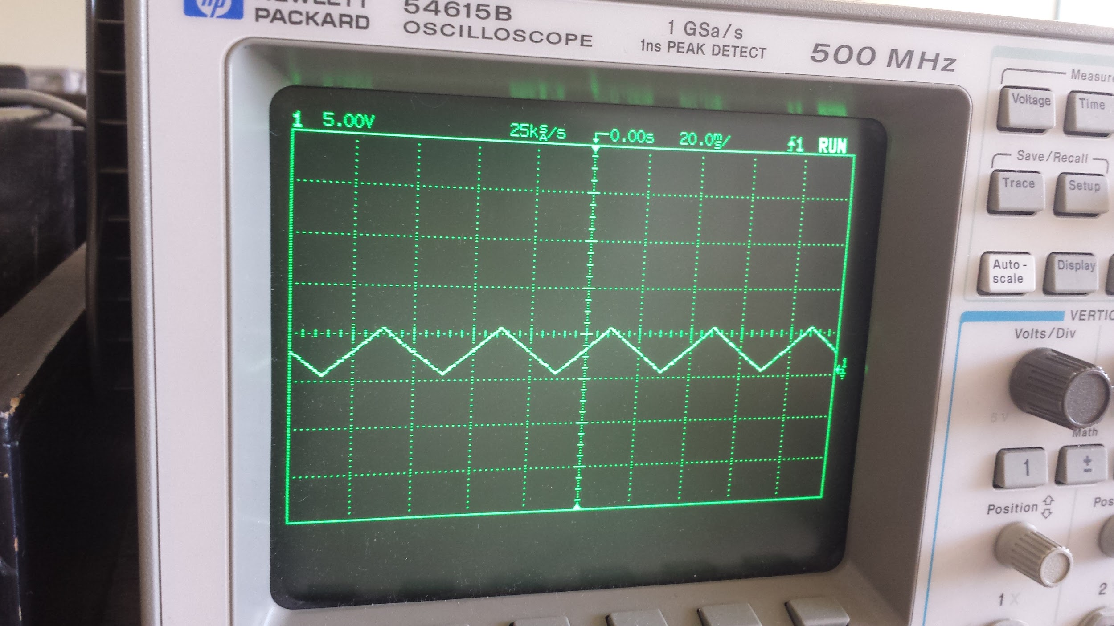
Figure 6. Image of Triangle Waveform
- Next our group tested the VCO. We jumper-ed the the output signal trace from the ATmega328P and MCP4921 module to the input of the VCO. We then attached a spectrum analyzer to the output SMA connector and powered up our PCB again. An image can be found below that show our VCO functioning.
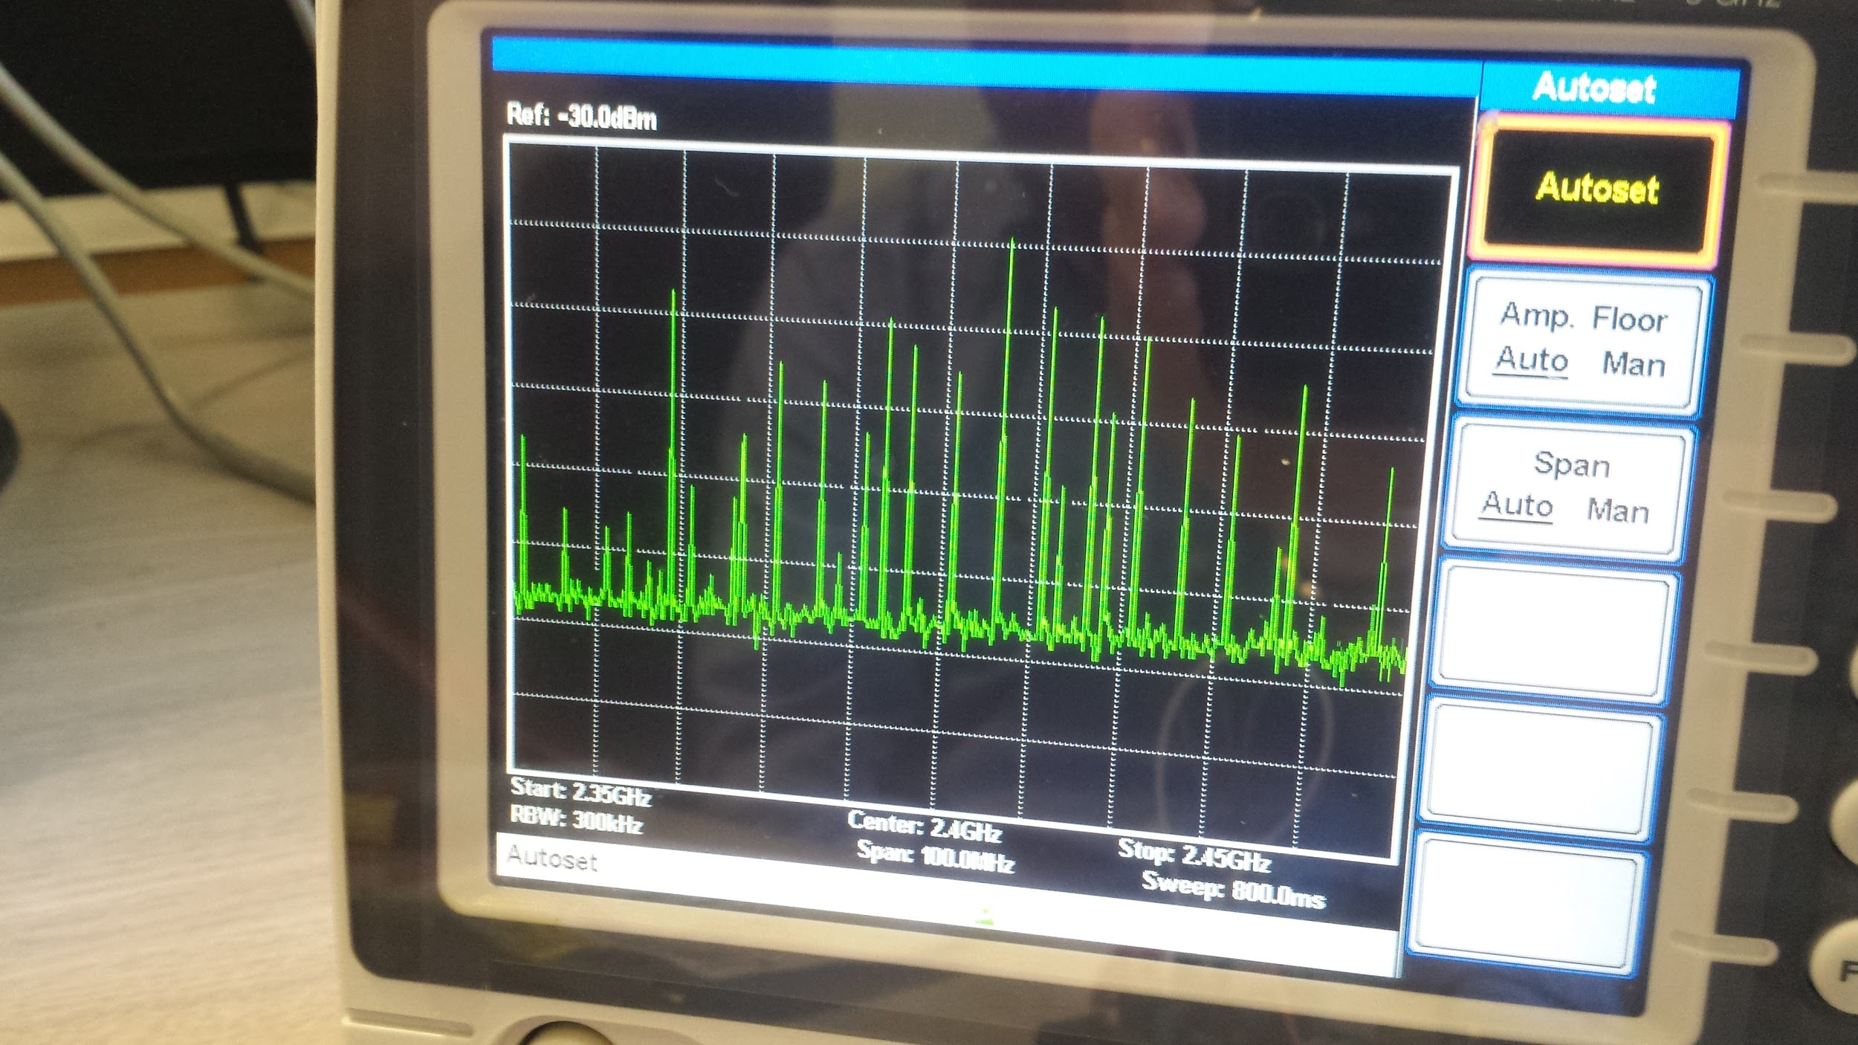
Figure 7. Image of VCO Functioning on Spectrum Analyzer
The data sheet says that the minimum and maximum operating frequencies are 2328MHz and 2536 MHz respectively. The image shows an approximate center frequency of 2.41GHz, which is fairly close to what our VCO should be producing. The other spikes in the image are the other frequencies of the RF signals produced by the VCO as the triangle wave ramps up and down on the Vtune input.
To further confirm that our VCO was functioning properly, we decided to supply different DC voltages and recorded the frequency of the generated signal. A table of the data recorded during the process can be found in Appendix A. After successful data collection, we then created a graph to see how closely the VCO was working to what was shown in the data sheet. This graph can be seen below:
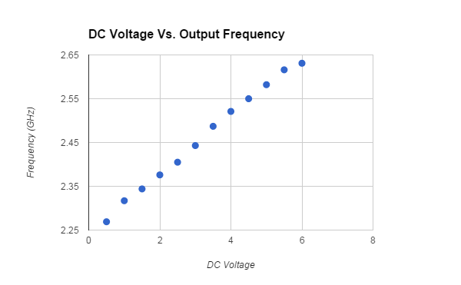
Figure 8. Graph of DC Voltage Vs. Output Frequency

Comparing this graph to the graph shown in the data sheet for the VCO it is clear that out VCO was functioning very close to what was specified for various DC voltages being supplied to Vtune. Both these tests also confirms that our power splitter functions properly as the signal from the VCO was being properly split and sent to the RF out SMA connector.
- Next we powered up the LNA circuit to confirm that it was boosting the strength of the output signal. In the image found in Figure 7 above, the reference power level is approximately -30dbm. With the LNA introduced to the RF circuitry, the new reference power level became approximately -10dbm. An image of this can be seen below:
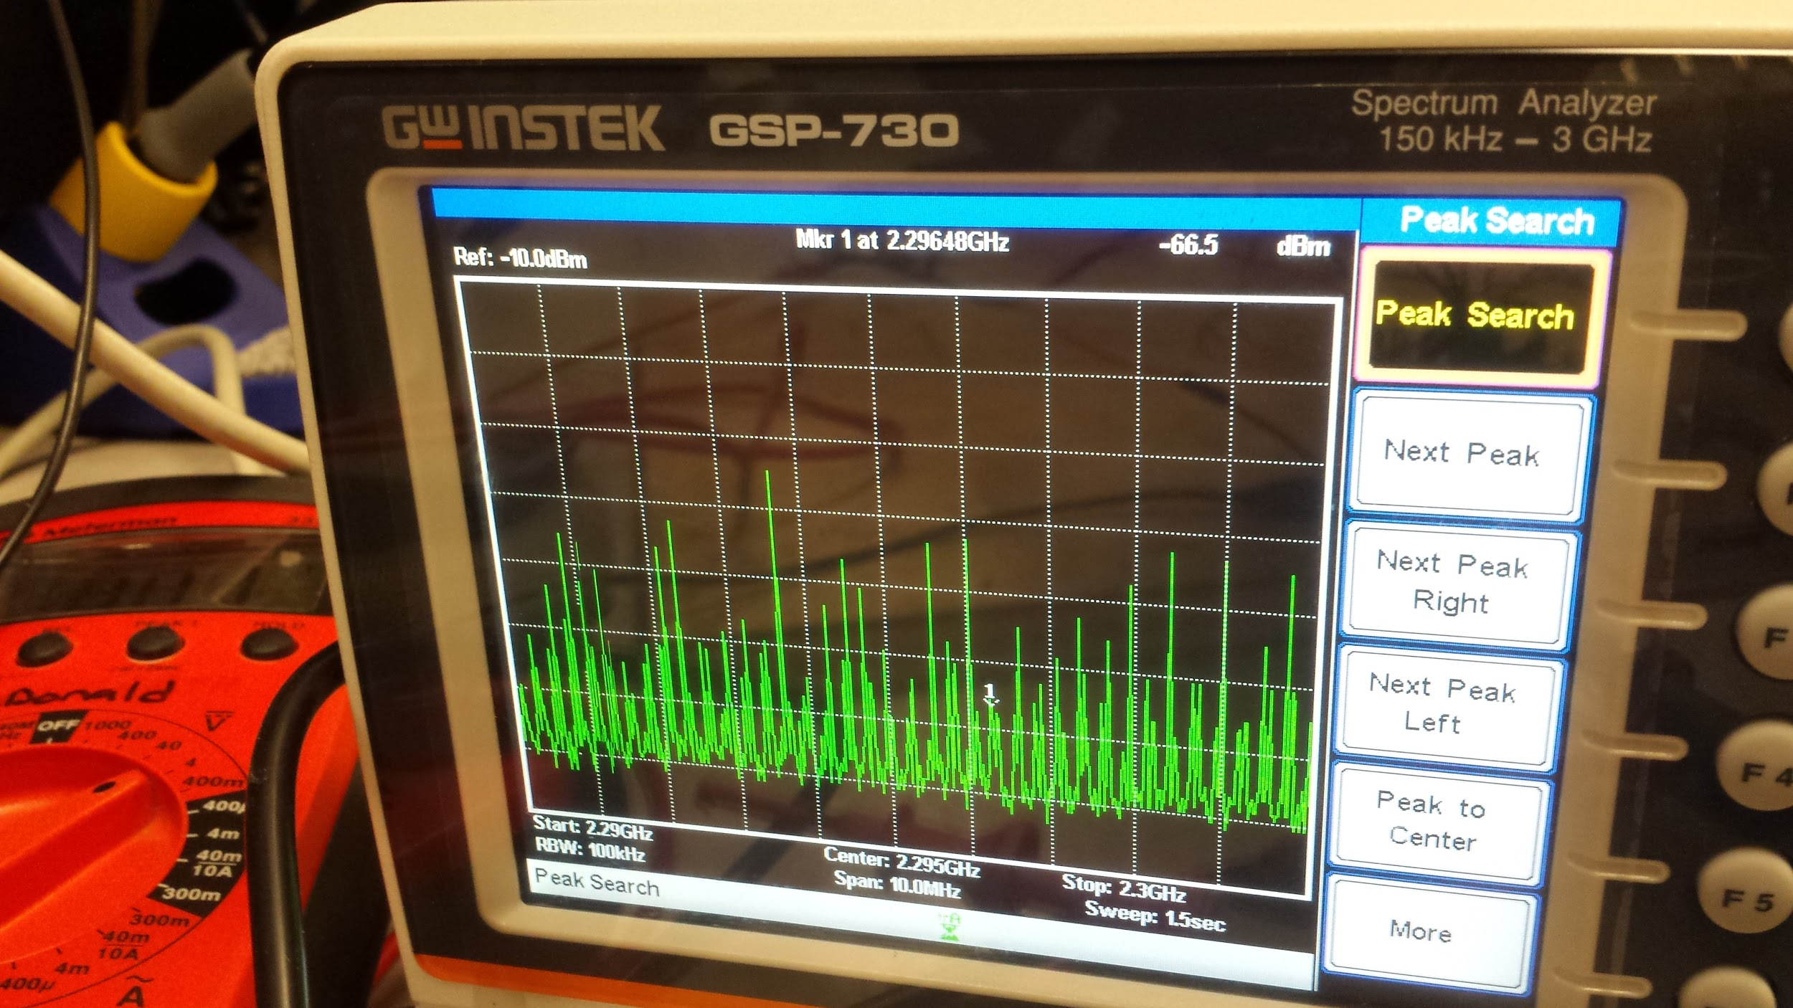
Figure 9. Image of LNA Changing Reference Power Level
Our group saw that this approximate 20dbm gain in output power when comparing the two different reference output powers as evidence to prove that the LNA was working properly. It would have been impractical to form a chart and graph that compared the output power levels of various frequencies with the LNA on or off. It would be nearly impossible to get the power output readings at the exact same frequencies using the spectrum analyzer with the LNA on or off.
- Next our group decided to test the low pass filter circuit on our PCB. Just as in lab 6, we tested our low pass filter by inputting a 3Vp-p signal and recorded the frequency response of the overall low pass filter. We calculated each data points respective gain and found the cutoff frequency for our systems. The approximate cutoff frequency for our low pass filter was 7500Hz. A table of all the data we collected that shows the approximate cutoff frequency can be found in Appendix B. Also included below is a graph of the collected data:
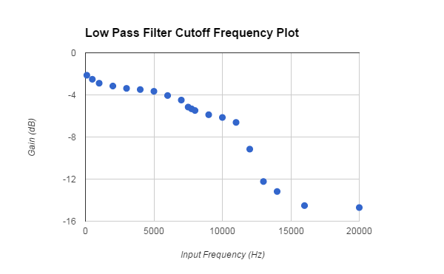
Figure 10. Graph of Cutoff Frequency for Low Pass Filter

The data in the table along with the graph above confirmed the functionality of the low pass filter on our PCB.
- Unfortunately due to the fact that there was no way to send in two test signals into our mixer and connect a spectrum analyzer to its output, there was no feasible way to test the functionality of our mixer with it installed on our PCB. This was the only component that we could not independently test on our PCB and we counted on the mixer to perform according to the specifications outlined in its datasheet. The RF and LO ports of the mixer would be able to take in signals in the frequency range of 1000-4200MHz and the IF port was good from DC-1500MHz. The only way we would find out if there were any potential issue with the mixer would be if our overall functionality test of the radar system had questionable results.
- With all parts of our PCB essentially tested and proved to be working as expected, we chose to test our radars functionality both in a room and outside. A picture of our final PCB on a 3D printed base as well as our final radar assembly can be seen in the figures below:
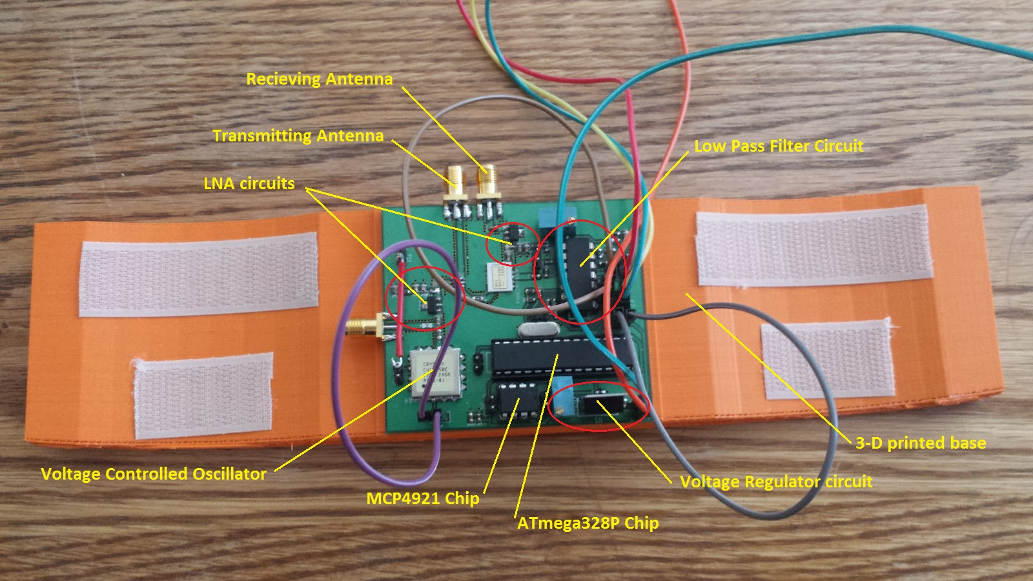
Figure 11. Final PCB and 3D Printed Base
The orange 3-D printed base was made of lightweight plastic. The curvature of the coffee cans were measured and used to print a nearly identical curvature in the base. To help secure the coffee cans to the base we used Velcro. The PCB fits snugly in between the two antennas.
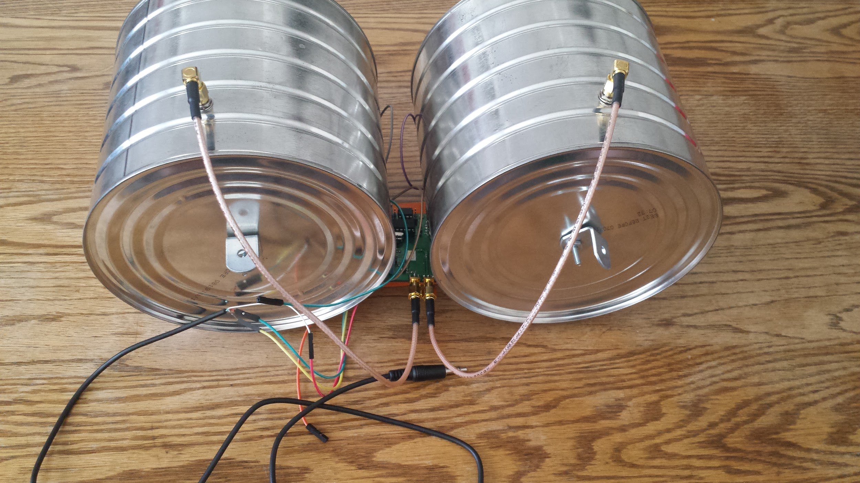
Figure 12. Final Radar Assembly
The test in lab was a metal chair being brought towards and taken away from the radar. The first test’s radar and Doppler imagines can be found in the figures below:
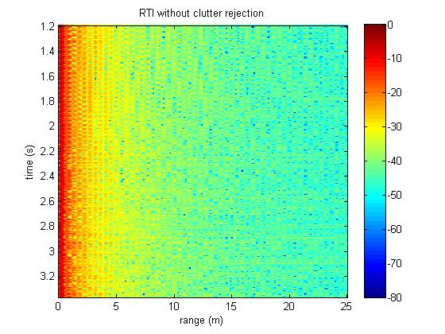
Figure 13. Indoor Test with Metal Chair, Range graph
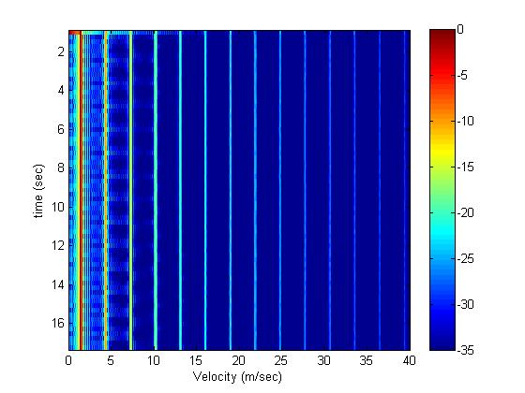
Figure 14. Indoor Test with Metal Chair, Doppler graph
These test results seemed reasonable for the tight space that we were in in the lab, although the graphs seemed harder to read than the ones observed in quarter one during lab 6 testing. A possible explanation for the difficulty in reading the graph is that there were many other metal objects in lab that could reflect the RF signal back. This would result in a lot of undesired noise. Looking at the Doppler graph, clearly there is an issue with picking up the velocity of the metal chair. It appears that the initial speed of the chair was picked up and then extended over the period of the test. The other lines also appear to be harmonics being picked up, most likely from the fact that the transmitting and receiving antennas being close in proximity. The Matlab code we used for the range and Doppler test can be found in Appendix D and Appendix E respectively.
Conducting further testing, We took the radar system outside in an attempt to get the distance and speed of various objects such as a stationary metal dumpster and cyclists passing by. After several tests, it became apparent that our radar had accuracy issues outside. Our first troubleshooting step was to disconnect the antennas and see if there was noise on the board that was producing a bad input signal into the computer we were using. The resulting MatLab images can be seen below:
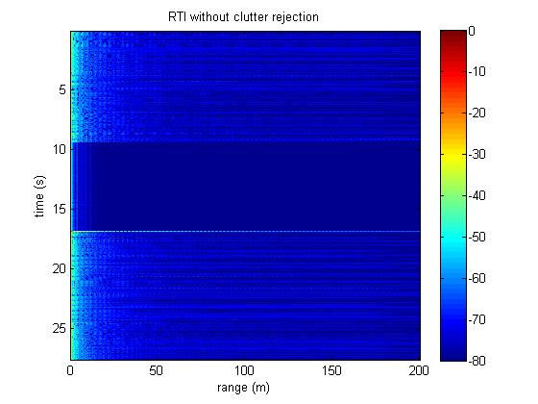
Figure 15.Clear Range Image, no Antennas Attached
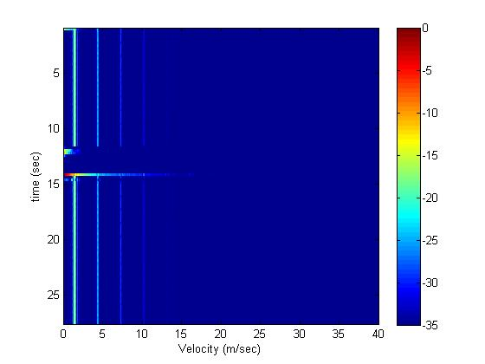
Figure 16. Clear Doppler, no Antennas Attached
Based on the images in the figures above, the PCB itself appeared to be fine and a bad signal was not being sent from the board into the computer, although there was a small amount of noise seen on both the Doppler and range images. Next we connected our antennas back up to the system and pointed them into the sky and then pointed them at an object several feet away to verify a noticeable difference in the MatLab images produced. The resulting MatLab image can be seen below:

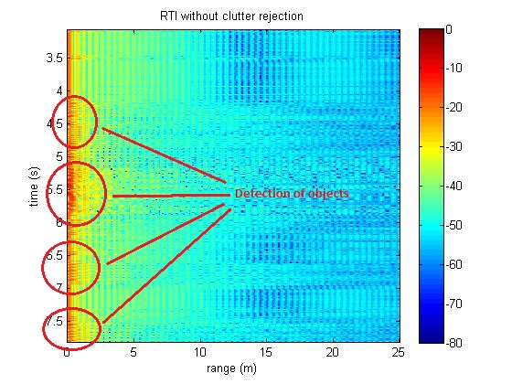
Figure 17. Range Image with Radar Being Pointed Between Sky and Object
It is clear by the variations in the red pixels in figure 17 that the radar does pick up objects when the radar is horizontal compared to when it is pointed at the sky. However, the image in figure 17 still doesn’t depict how well the radar detects objects at a given distance. Next we decided to conduct an outdoor test using a car in an open parking lot. Unfortunately the results of this test were inconclusive when the car was driven far from the radar. Then we noticed that at a very close distances, the radar would detect a moving object. Our final test to show that the radar had some practical functionality was moving a cell phone in front of the antennas. The resulting images can be seen in the figures below:
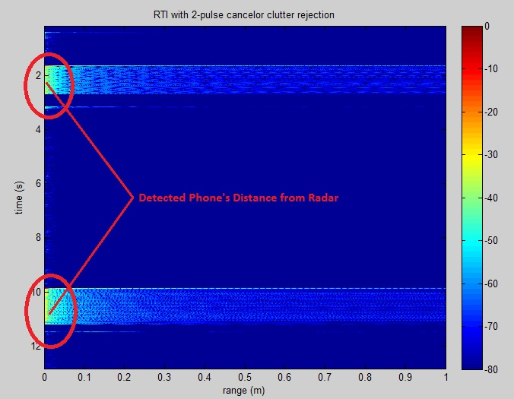
Figure 18. Cell Phone’s Range Detected by Radar
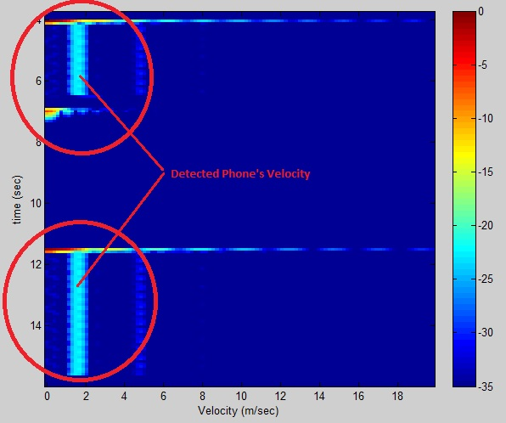
Figure 19.Cell Phone’s Velocity Detected by Radar
Figure 18 above shows the detection of the cell phone two different times during the test and at varying distances. Based on the graph scale and the resulting image, the first detection was approximately 4 meters away at 2 seconds into the test. The second detection was approximately 3 meters away at 10 seconds into the test. Although the range graph is still not easy to interpret, this is the cleanest and most accurate range image produced with and object. Figure 19 above shows the Doppler image from the same cell phone test. The cell phones velocity is detected the two times it was passed in front of the radar system. However almost a constant velocity is seen again on this Doppler image. This is the cleanest Doppler image produced from any test without any harmonics. Though figures 18 and 19 above are promising results that our radar system is working, it is clear that there are still some issues with detection of objects, especially objects at a distance.
Conclusion
Overall our new radar design ultimately worked, however the accuracy of the results were questionable. At close distances our radar appeared to determine an approximate range and speed of a moving target. It was when the radar was placed outside for testing where it did not seem to do very well. Between the extra noise introduced with being outside as well as a potential issue with out mixer, it was hard to make sense of our MatLab readings. Based on all our bench testing, a majority of our PCB worked exactly as expected. With more investigation and time, our radar could be more accurate over greater distances. Another thing to note is that our final radar assembly only cost $117.30 to build, not including the cost of the PCB fabrication and extra parts we got from the lab supply. The complete price breakdown can be found in our bill of materials in Appendix C.
Future extension of the radar project section:
In order to fine tune our radar in the future, our group should create a test board that we could have used to bench test our MAC-42MH mixer. Due to our mixed results when field testing our radar system, I feel our mixer may be a source of issue as we were not able to prove it was actually performing to it specifications. Another thing we could look into changing would be the types of antennas used instead of using the coffee cans from quarter one. Also with the addition of new antennas, we would need to have the transmitting and receiving antennas further apart than we had them for our final radar assembly. Doing these two things would most likely reduce the amount of noise we kept seeing with our range and doppler readings.
Another couple of options our group could explore would be the implementation of a PLL in order to reduce the number of harmonic signals being transmitted out of the radar system. Our group wanted to try and implement a PLL in our quarter two design, but ultimately did not do so as we did not understand enough to successfully use one. Also if we chose to design our radar to operate at a higher frequency as well as use more power amplifiers, we could improve the range and accuracy of system. The only trade off in doing this would be that power consumption would increase.
Suggestions for the class:
Overall the structure of 134 senior design class was put together well. Our group enjoyed our experience throughout the two plus quarters of this course. Other than the occasional typos in the lab manuals that were correct as they were found, our group only has a few suggestions for improvements to this class. First, a better understanding and familiarity when using Kicad needs to occur. The two PCB designs in quarter one wasnt enough practice for our group to confidently design our quarter two PCB. We would suggest to add at least one more PCB design in quarter one, perhaps of the low pass filter used in lab 6. If a future group could design and successfully build that, they would have much better KiCad and PCB manufacturing skills for the following quarter.
Another suggestion for this course would be more guidance and or deadlines in the second quarter of the project. It was easy for many groups to lose focus when designing their new radar systems and get caught up in other coursework. If hard deadlines along with a grade were assigned for various aspects of the second quarter design, groups would have to keep on top of their work. Things such as block diagrams, estimated parts list, rough draft of PCB design etc could be required by certain dates to ensure that all groups are staying on task with their work in order to finish their radar design by the end of the second quarter. Having our senior design go into a third quarter along with having a full load of other courses is tough and it would be greatly appreciated by next year's students if this did not occur.
References
Acknowledgments:
Our group would like to acknowledge Professor Leo for all his help and guidance in getting our group’s radar to work. There were numerous issues that he caught prior to our PCB being sent out for manufacturing. He also guided us in trouble shooting our final PCB assembly when it appeared there was a catastrophic shorts on our board.
We would also like to acknowledge Jay for his help in tracking down the many parts in the college’s inventory that our PCB design required. He also answered countless questions that arose during the course of this senior design project.
We would also like to acknowledge Mini-Circuits for providing our group with two sample MAC-42MH mixers as well as 4 SP-2U2+ power splitters, which saved our group significant cost in purchasing unnecessarily large amounts of these components.
We would also like to acknowledge Texas Instrument for providing us with two sample OPA4228 chips to be used in our radar. There were no more OPA4228 chips available and new ones were not only expensive, but would have also been on back order for weeks. Using the sample option through TI allowed us to get two OPA4228 chips to use for no cost within a week of placing our parts order, saving us time and money.
Reference Material:
~Voltage regulator circuit design and associated documentation on the Arduino setup used to produce a triangular wave in the lab 1 manual from the first quarter.
~CVCO55CC-2328-2536 VCO data sheet which can be found at: http://www.crystek.com/microwave/admin/webapps/welcome/files/vco/CVCO55CC-2328-2536.pdf
~LNA power amplifier circuit design in lab 2 from the first quarter.
~SP-2U2+ Power Splitter data sheet which can be found at: http://www.datasheets360.com/pdf/-7998948974973782836
MAC-42MH mixer data sheet which can be found at: http://www.minicircuits.com/pdfs/MAC-42+.pdf
~Low Pass Filter design in lab 6 from the first quarter
Appendixes

Appendix A (Table of Data Collected on VCO functionality)

DC Voltage (for Vtune) | Output Frequency (GHz)
.5 | 2.269
1.0 | 2.317
1.5 | 2.344
2.0 | 2.376
2.5 | 2.405
3.0 | 2.443
3.5 | 2.487
4.0 | 2.521
4.5 | 2.550
5.0 | 2.582
5.5 | 2.616
6.0 | 2.631

Appendix B (Table of Output Voltages and Gain with Respect to 3Vp-p Input Signal)

Frequency (Hz) | Vp-p (V) | Gain (20*log(xV/3V))
100 | 2.347 | -2.132
500 | 2.246 | -2.514
1000 | 2.151 | -2.889
2000 | 2.086 | -3.156
3000 | 2.033 | -3.379
4000 | 2.007 | -3.491
5000 | 1.969 | -3.657
6000 | 1.880 | -4.059
7000 | 1.789 | -4.490
7500 | 1.657 | -5.156
7750 | 1.625 | -5.325
8000 | 1.596 | -5.482
9000 | 1.524 | -5.883
10000 | 1.479 | -6.143
11000 | 1.401 | -6.614
12000 | 1.046 | -9.152
13000 | 0.734 | -12.229
14000 | 0.658 | -13.178
16000 | 0.564 | -14.517
20000 | 0.552 | -14.704

Appendix C (Bill of Materials, Total: $117.30)
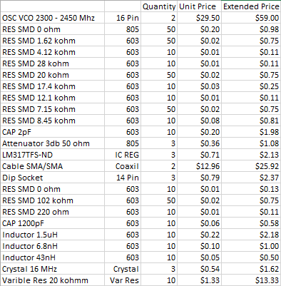

Appendix D (MatLab Code Used for Range Image)

clear all;
close all;
% read the raw data .wav file here
[Y,FS,NBITS] = wavread('running_outside_20ms.wav');
%constants
c = 3E8; %(m/s) speed of light
%radar parameters
Tp = 20E-3; %(s) pulse time
N = Tp*FS; %# of samples per pulse
fstart = 2260E6; %(Hz) LFM start frequency
fstop = 2590E6; %(Hz) LFM stop frequency
BW = fstop-fstart; %(Hz) transmti bandwidth
f = linspace(fstart, fstop, N/2); %instantaneous transmit frequency
%range resolution
rr = c/(2*BW);
max_range = rr*N/2;
%the input appears to be inverted
trig = -1*Y(:,1);
s = -1*Y(:,2);
clear Y;
%parse the data here by triggering off rising edge of sync pulse
count = 0;
thresh = 0;
start = (trig > thresh);
for ii = 100:(size(start,1)-N)
if start(ii) == 1 & mean(start(ii-11:ii-1)) == 0
%start2(ii) = 1;
count = count + 1;
sif(count,:) = s(ii:ii+N-1);
time(count) = ii*1/FS;
end
end
%check to see if triggering works
% plot(trig,'.b');
% hold on;si
% plot(start2,'.r');
% hold off;
% grid on;
%subtract the average
ave = mean(sif,1);
for ii = 1:size(sif,1);
sif(ii,:) = sif(ii,:) - ave;
end
zpad = 8*N/2;
%RTI plot
figure(10);
v = dbv(ifft(sif,zpad,2));
S = v(:,1:size(v,2)/2);
m = max(max(v));
imagesc(linspace(0,max_range,zpad),time,S-m,[-80, 0]);
colorbar;
ylabel('time (s)');
xlabel('range (m)');
title('RTI without clutter rejection');
%2 pulse cancelor RTI plot
figure(20);
sif2 = sif(2:size(sif,1),:)-sif(1:size(sif,1)-1,:);
v = ifft(sif2,zpad,2);
S=v;
R = linspace(0,max_range,zpad);
for ii = 1:size(S,1)
%S(ii,:) = S(ii,:).*R.^(3/2); %Optional: magnitude scale to range
end
S = dbv(S(:,1:size(v,2)/2));
m = max(max(S));
imagesc(R,time,S-m,[-80, 0]);
colorbar;
ylabel('time (s)');
xlabel('range (m)');
title('RTI with 2-pulse cancelor clutter rejection');

Appendix E (MatLab Code Used for Doppler Image)

%Process Doppler vs. Time Intensity (DTI) plot
clear all;
close all;
%read the raw data .wave file here
[Y,FS,NBITS] = wavread('Off of Newton Exit 17.wav');
%constants
c = 3E8; %(m/s) speed of light
%radar parameters
Tp = 0.250; %(s) pulse time
N = Tp*FS; %# of samples per pulse
fc = 2590E6; %(Hz) Center frequency (connected VCO Vtune to +5)
%the input appears to be inverted
s = -1*Y(:,2);
clear Y;
%creat doppler vs. time plot data set here
for ii = 1:round(size(s,1)/N)-1
sif(ii,:) = s(1+(ii-1)*N:ii*N);
end
%subtract the average DC term here
sif = sif - mean(s);
zpad = 8*N/2;
%doppler vs. time plot:
v = dbv(ifft(sif,zpad,2));
v = v(:,1:size(v,2)/2);
mmax = max(max(v));
%calculate velocity
delta_f = linspace(0, FS/2, size(v,2)); %(Hz)
lambda=c/fc;
velocity = delta_f*lambda/2;
%calculate time
time = linspace(1,Tp*size(v,1),size(v,1)); %(sec)
%plot
imagesc(velocity,time,v-mmax,[-35, 0]);
colorbar;
xlim([0 40]); %limit velocity axis
xlabel('Velocity (m/sec)');
ylabel('time (sec)');

