Application Note: Kurt Norris
Summary of Project: Our senior design project consisted of building and testing a radar system. After learning about the various RF parts that would be at our disposal we were instructed to design a radar system to be tested in a competition. Some of the goals of the competition included weight, power consumption, and accuracy.
Since much of my group was unable to attend our weekly progress presentations, designing the presentations as well as delivering them was one of my main duties each week. Another important task was bringing the feedback information back to the group after the presentations were made.
To create a presentation for the given week, slide one would always consist of a title page containing our team picture, our team name, as well as the week that the report was being presented. Next our weekly progress was laid out in the following slides. Most often, this included new parts that had been found to be added to the project. Along with a picture of the new part, a small description of the part, along with some of its essential parameters from the data sheet, were listed. This is important to show compatibility between the parts that were selected.
Besides new parts, new ideas, such as where we wanted to go with the project, were conveyed in each presentation. This allowed our professor and class to give feedback on what the group was working on each step of the way. This is an important step because little details can be easily overlooked by a group working to compile all these items together.
Another slide that was of great importance was the block diagram of the system.
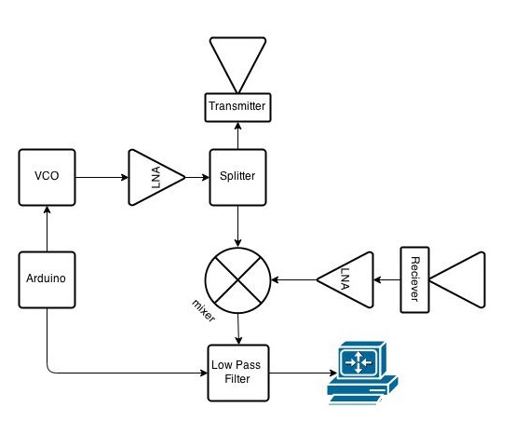
Making block diagrams and checking for power input and output was another job I took on for the project. Creating the flow chart including the power calculations was another way to see if the system would have enough power to actually work effectively. To make the block diagram, a Google Block Diagram App was used. This made an easy transition into our team’s Google doc where we compiled much of our report and data inputs. Having a block diagram as a slide was another check point for the professor and class to see to double check that the system would perform as we intended.
Finally, the presentation would include a “Goals for next week” section in which the team had previously dictated what each member would be working on for the given week. When accomplished, these “goals” would be added into the next week’s presentation and the cycle would begin again.
After giving each presentation, feedback from the professor and class were brought back to the group in order to change overlooked parameters of the project or add new ideas in. For example, if a part didn’t quite meet the specification we wanted, we could then work on finding a better working part. This happened, for example, with our PLL (Phase Loop Locked). After presenting, we found that our PLL didn’t meet some of the specifications we needed. Also the biasing circuit was quite complex. For these reasons we decided to stick to a more simplistic version and just use a VCO (Voltage Controlled Oscillator) as we did in the quarter one system. Feedback through the presentations and simplicity of our design are what ultimately led us to have a working system.

